Total Hip Replacement

Physiotherapy Information and Advice

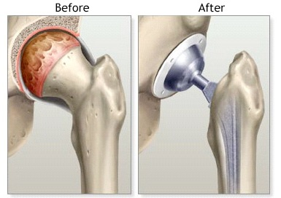

A total hip replacement is a common but major operation. It involves replacing the worn surfaces of your hip joint.

By replacing your hip joint, the intention is to help reduce pain and allow you to continue with normal daily activities. Following the operation a course of rehabilitation required.

Your Physiotherapist will give you advice and help you to regain the movement and strength in your hip. By strengthening the muscles around your hip through a graduated rehabilitation programme, you will help to control its stability and improve the range of movement.

This leaflet aims is to help advise you on your rehabilitation.

General Advice

Your stay in hospital is usually 3-4 days

Before coming into hospital you will need to make plans for your discharge

You will need someone to drive you home on the day of discharge

You may need help with personal care and activities of daily living for a few weeks after discharge; you need to plan for this with your family and/or friends.

You will be advised on an exercise programme which you need to undertake yourself, on a regular basis

You will be expected to walk within 24 hours of your operation using a frame or crutches

The hip is often more painful a few days after surgery, this is normal as you will be increasing your activity

Take the pain relief as prescribed for you; this will help you to exercise more
comfortably

If you need on-going physiotherapy after your discharge from hospital, this will be arranged close to where you live

On receipt of the referral the physiotherapist will contact you by telephone/post to arrange a mutually convenient time

The frequency of your physiotherapy appointments will be determined by the outpatient physiotherapist according to your need

Continue with your exercises given to you by your ward physiotherapist until you see the out-patient physiotherapist

On the Ward

Your Physiotherapist will demonstrate exercises which will help to strengthen and move your hip. You will be encouraged to get up and start walking with a frame or crutches. You can gradually increase the weight bearing through your operated leg as you are able.

Once you are comfortable using crutches and can perform the exercises, you will be shown how to climb the stairs safely using your crutches.

It is important to continue the exercises at home to progress the strength and mobility of your hip.

Normal activities of daily living are the best rehabilitation.

Precautions

It is important that you avoid deep bending movements of your hip and twisting activities for 3 months following your surgery.
Consider the height of the chairs you sit on as low chairs may cause you to bend your hip too much.
Be careful when washing and dressing as reaching down below your knees will cause deep bending of your hip joint.

Exercises

DAY 1 – until full recovery

- Ankle Pumps
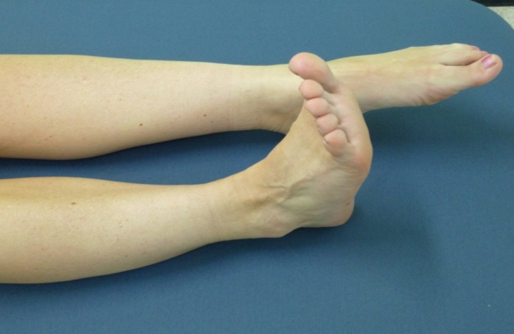
Bend your ankles up and down briskly as far as able.
Repeat 20 times.

DAY 1 – until full recovery

- Static Quads
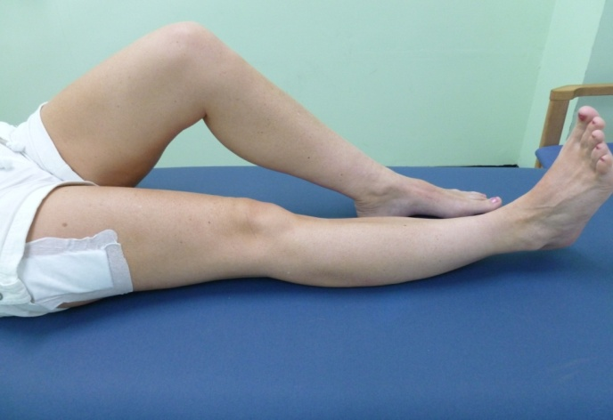
Press knee into bed, tightening the muscle on front of your thigh.
Hold for 3 seconds. Do not hold your breath.
Repeat 10 times.

DAY 1 – until full recovery

- Gluteal Squeeze

Squeeze buttock muscles as tightly as possible and hold for 3 seconds.
Do not hold your breath.
Repeat 10 times.

DAY 5– until full recovery

- Inner Range Quads
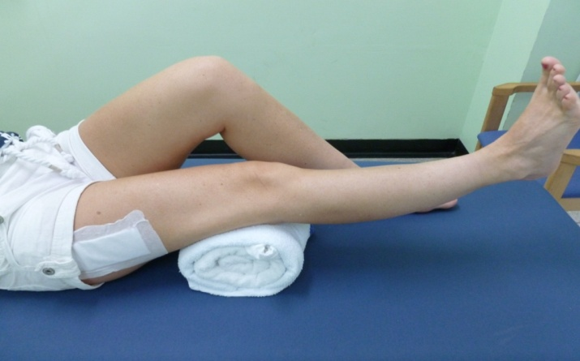
Lie on your back or sit with a roll under the knee (operated limb). Lift your foot, straightening the knee and hold for 3 seconds.
Do not raise your thigh off the roll. Do not hold your breath.
Repeat 10 times.

DAY 5– until full recovery

- Hip Flexion
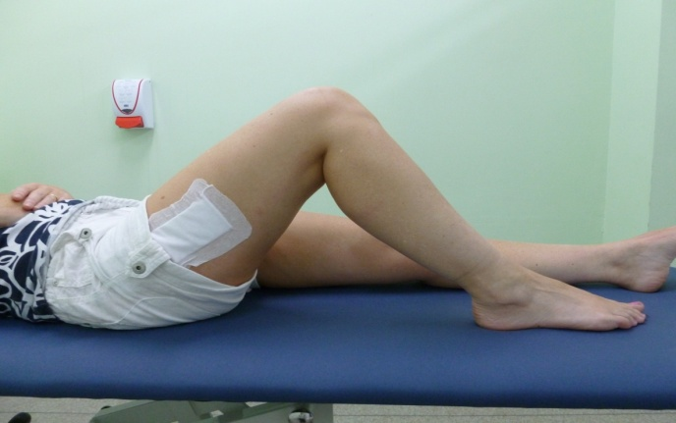
Lie on your back. Bend your knee and slide heel toward buttocks.
Repeat 10 times.

DAY 5– until full recovery

- Knee extension in sitting
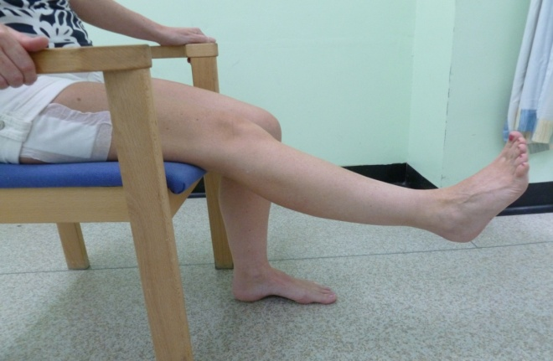
Sit with your back against chair. Straighten your knee slowly.
Repeat 10 times.

DAY 5– until full recovery

- Hip flexion in standing
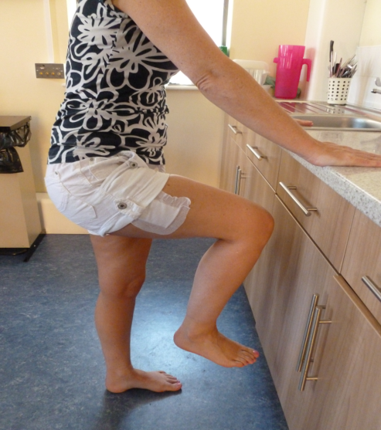
In standing, holding on to firm surface, lift the operated knee as high as you can but no higher than your hip. Keep your body upright during exercise.
Repeat 10 times.

DAY 5– until full recovery

- Hip extension in standing
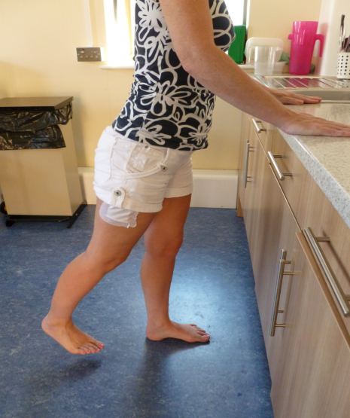
In standing, holding on to firm surface, move the operated leg out behind you, than back to the centre.
Keep your body straight during exercise.
Repeat 10 times.

DAY 5 – until full recovery

- Hip abduction in standing
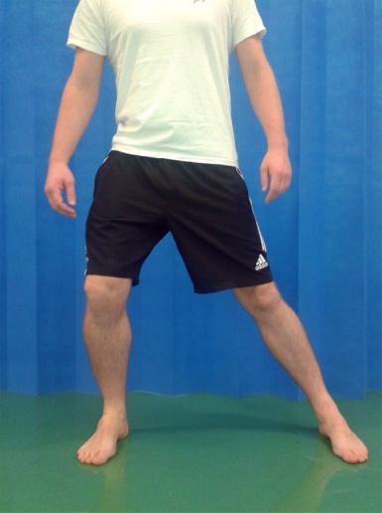
In standing, holding on to a firm surface, slide your operated leg away, keeping your foot on the floor. Slide back to start position. Repeat 10 times.

Driving

You may return to driving when you have sufficient flexibility and strength in your knee and you are putting full weight through your knee. This is usually after 6-8 weeks. To ensure that you are safe to return to driving you must be able to perform an emergency stop. It is advised that you contact your insurance company to check that you are fully covered after your operation.
Lying on your back with your legs straight, bend your ankles upwards and push your knees firmly against the bed.
Hold for 10 seconds. Repeat 10 times.

Work

Returning to work will depend on what this activity involves.
For sedentary jobs it is usually 6 weeks, allowing for the fact that the leg should be elevated for periods and you should be able to mobilise regularly throughout the day.

Contacts
If you have any concerns following discharge from hospital the in-patient physiotherapy team can be contacted on :-

• 01792 703124 for Morriston Hospital
• 01792 285383 for Singleton Hospital
• 01792 479040 for Sancta Maria Hospital
• 01792 472922 for St. Davids house
• 029 2083 6700 for the Vale Hospital

Document history
Author: Sharon Maggs
Department: Physiotherapy Department

Notes:

Publication Date: March 2016
Issue: 1

